SPRINT-3

| Date | 09 November 2022 |
| --- | --- |
| TEAM ID | PNT2022TMID37769 |
| Project Name | IoT Based smart crop Protection system for agriculture |
| Maximum mark | 20 marks |

STEP1: Simulated program to get the random values.

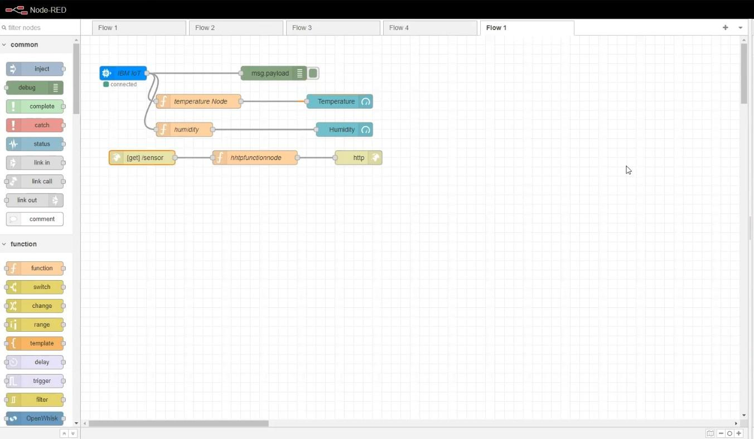

STEP2: Generate debug message from IBM Watson IoT Platform and connect the nodes.

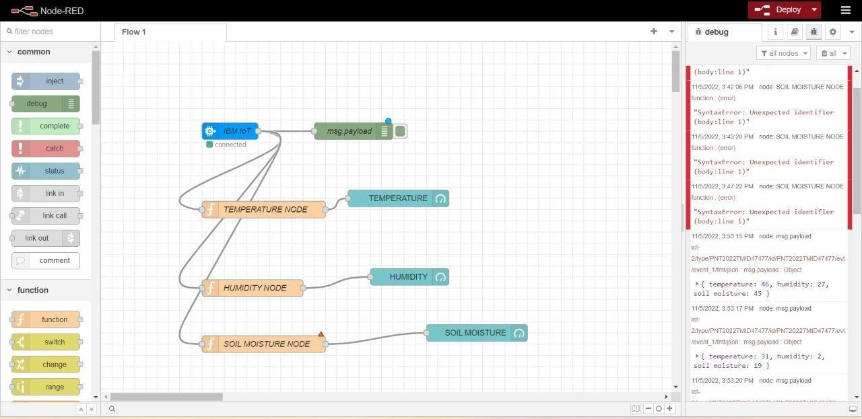

STEP3: Generate the some output from recent events.

